24-678: Computer Vision for Engineers

Ryan Wu

ID: weihuanw

PS2 Report

Due: Sep 22 2023

This file contains the following:

* night-vision-color.png
* thermal-color.png
* x-ray-color.png
* topography-color.png
* cracks-color.png
* readme.txt
* source code file(s) (attached to the end)

**PS2-1 Converting a Greyscale Image to a Pseudo-color Image**

(1) Ask the user for an input grayscale image and display the input image in the first window.

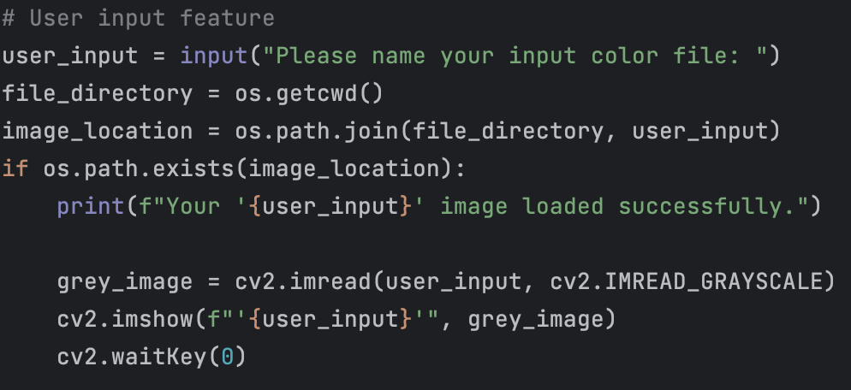

Figure . Code used for asking user input and loading the image.

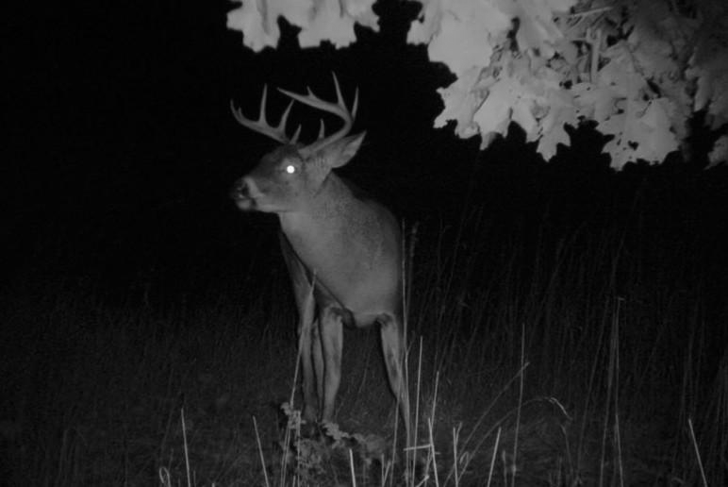

Figure . Night vision grayscale image.

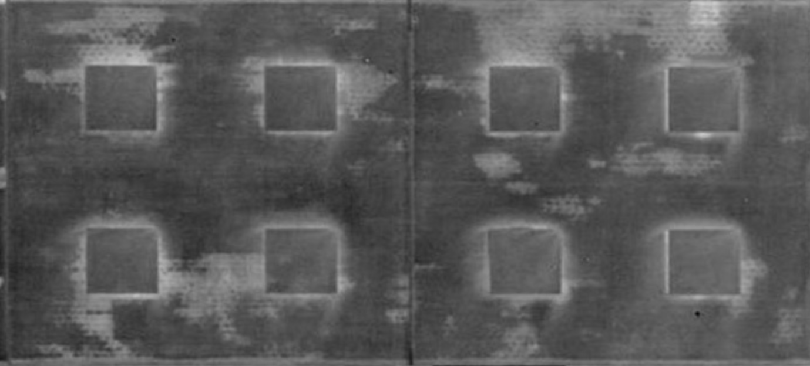

Figure . Thermal color grayscale image.

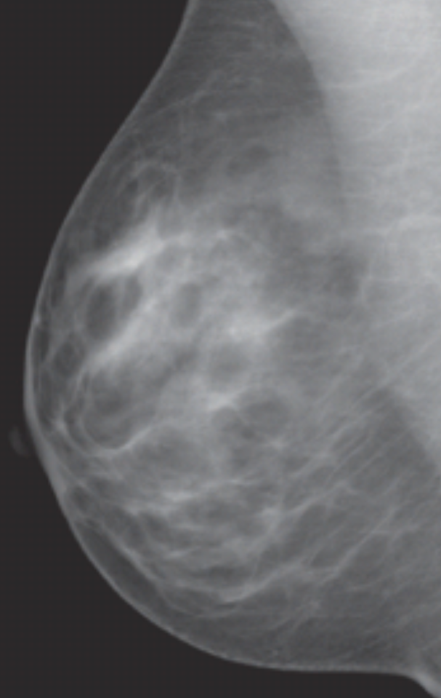

Figure . X-ray grayscale image.

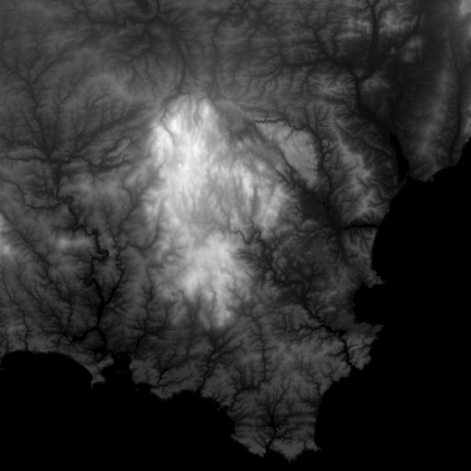

Figure . Topography grayscale image.

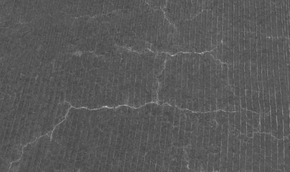

Figure . Cracks grayscale image.

(2) Find the lowest pixel value and the highest pixel value in the grayscale image.

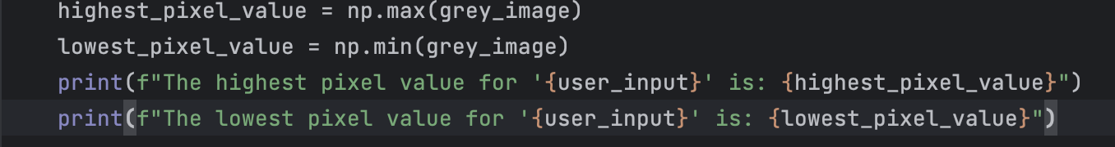

Figure . Code used to find the highest and lowest pixel values.

Table . Highest and lowest pixel values of each image.

|  |  |  |
| --- | --- | --- |
| **Image name** | **Highest Pixel Value** | **Lowest Pixel Value** |
| night-vision.png | 248 | 0 |
| thermal.png | 207 | 8 |
| x-ray.png | 203 | 38 |
| topography.png | 252 | 0 |
| cracks.png | 203 | 53 |

(3) Make a look-up table to convert the lowest gray value to blue and the highest gray value to red. The other gray values should be mapped to rainbow colors by the method explained in the lecture.

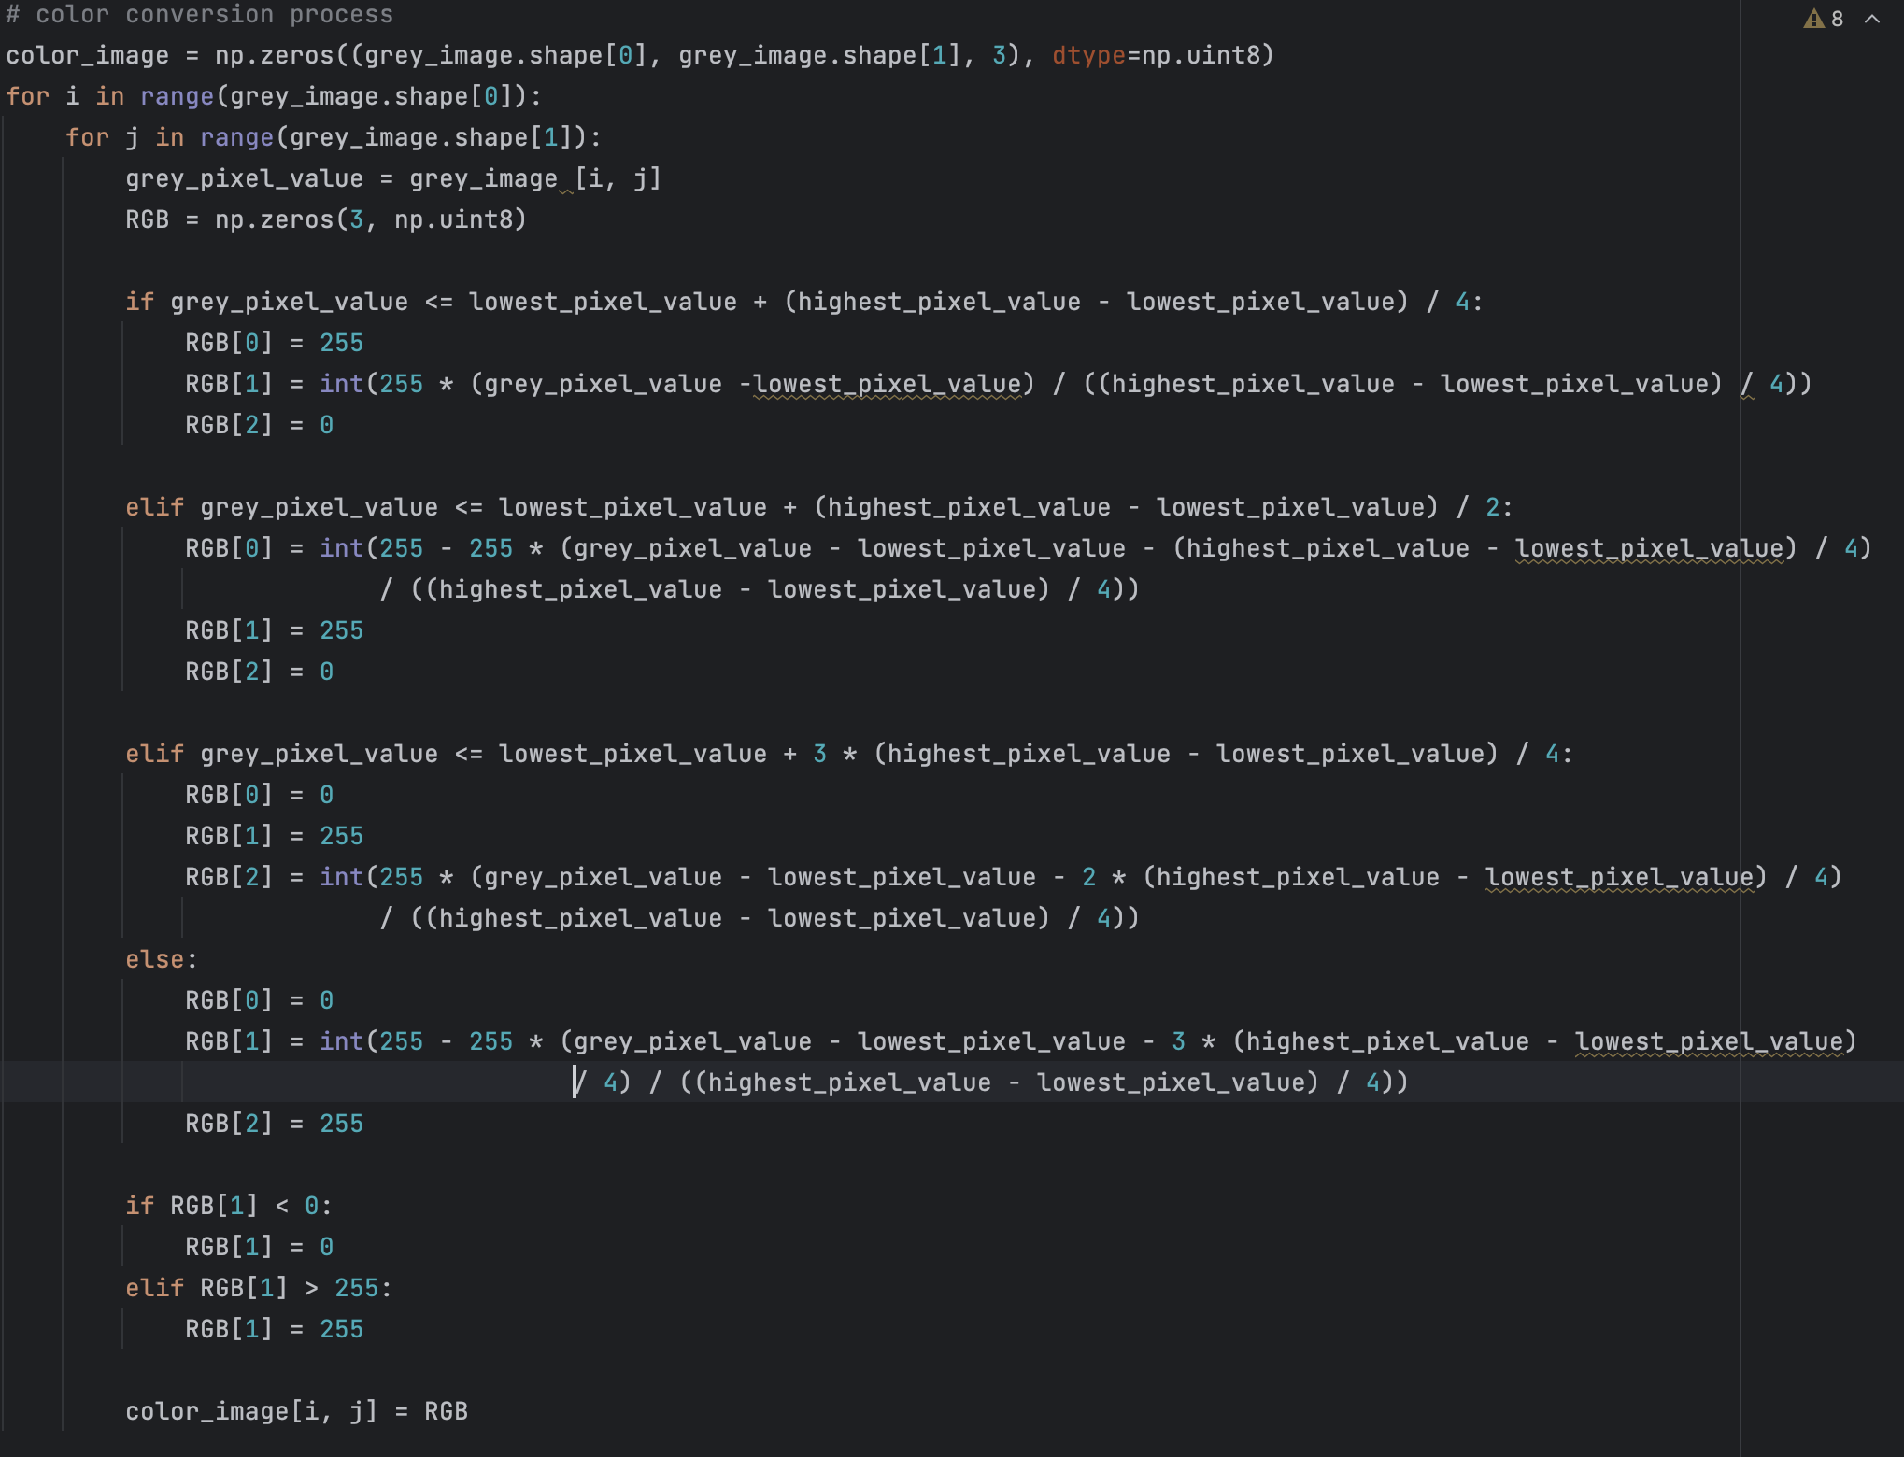

Figure . Code used for LUT and pixel color conversion.

(4) Using OpenCV functions, draw a cross in a circle to indicate the pixel of the highest gray value. Draw the cross and circle with white. If multiple pixels share the same highest gray value, place the cross and circle at the center of gravity of these pixels.

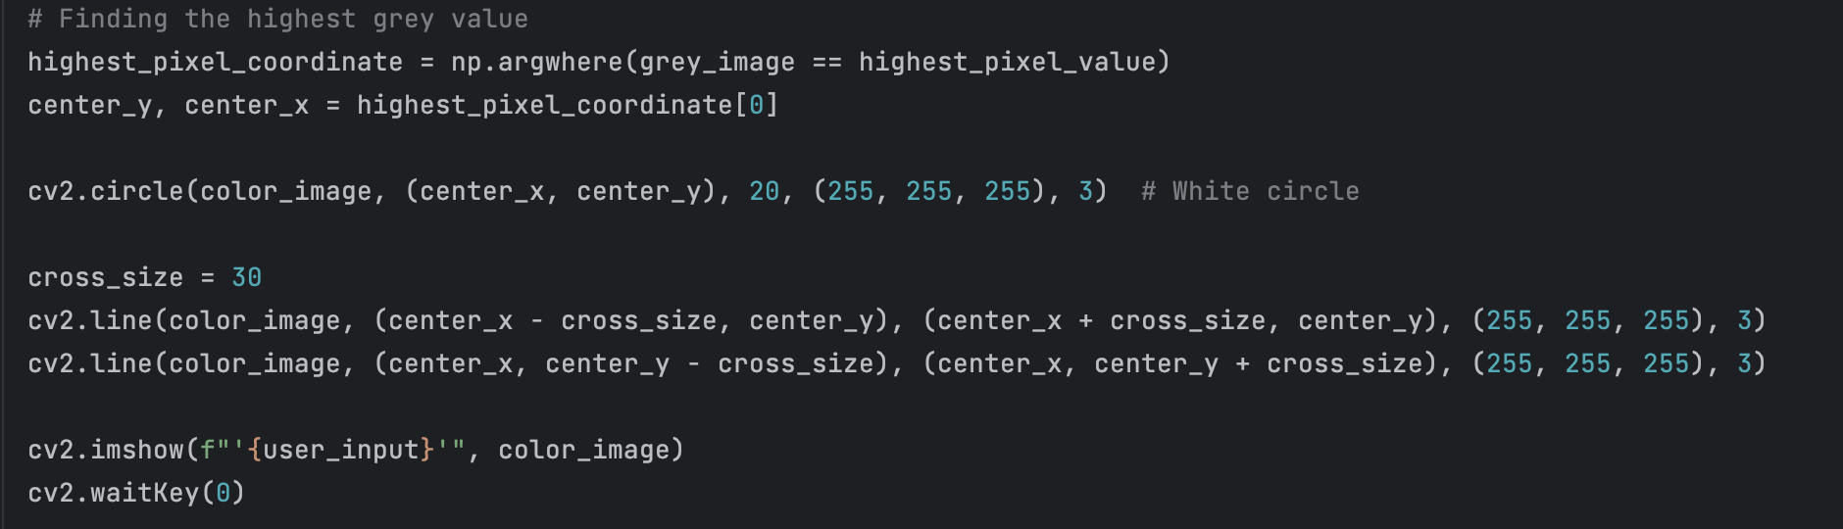

Figure . Code used for color image output.

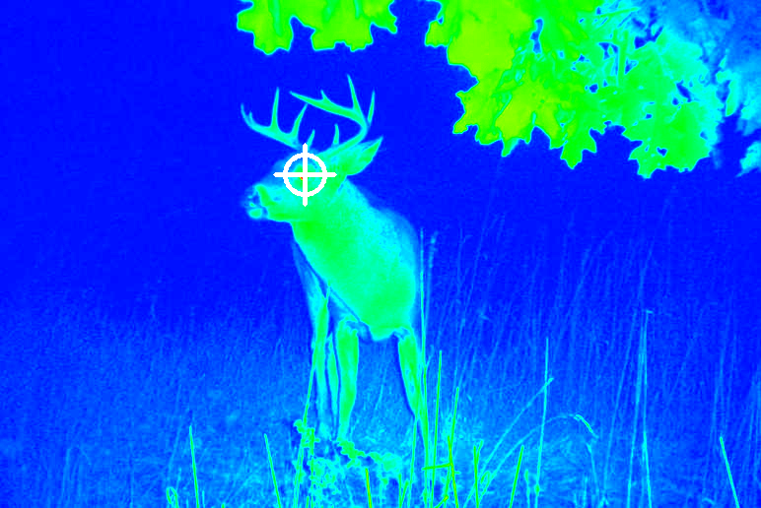

Figure . Night vision color image with the highest gray value labeled.

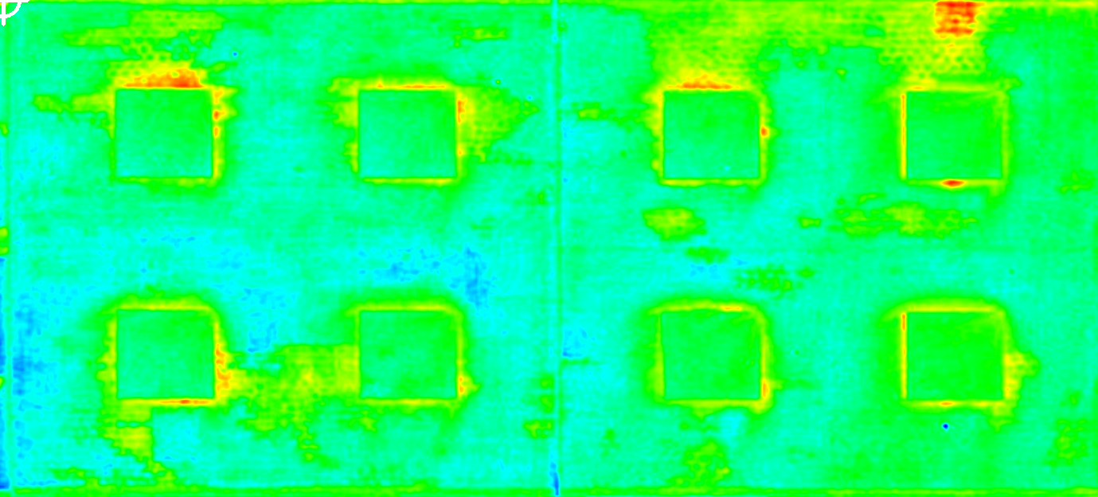

Figure . Thermal color image with the highest gray value labeled (top left corner).

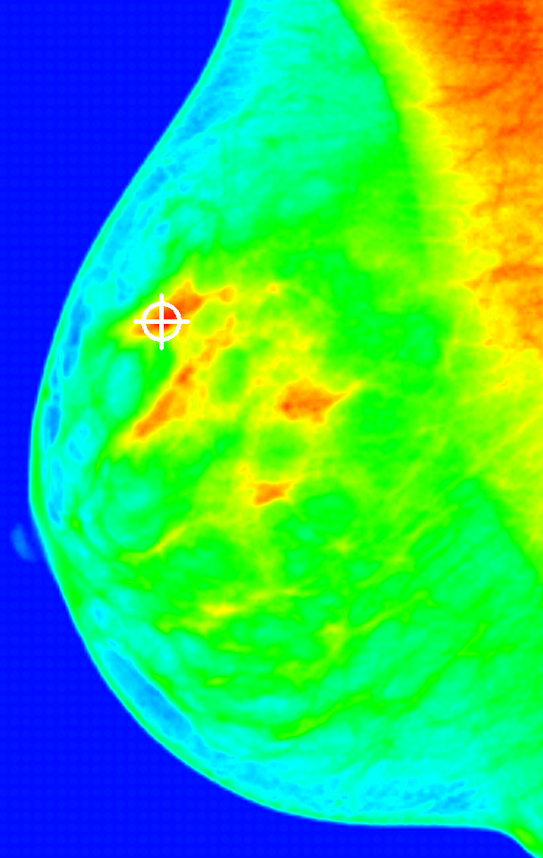

Figure . X-ray color image with the highest gray value labeled.

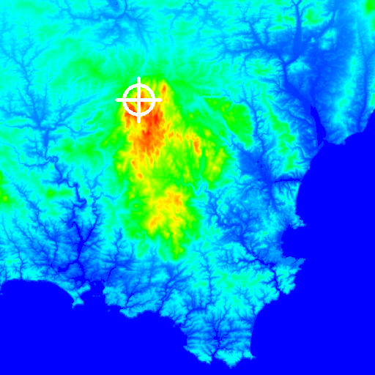

Figure . Topography color image with the highest gray value labeled.

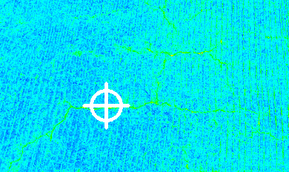

Figure . Cracks color image with the highest gray value labeled.

(5) Save the final color image as input-filename-color.png and display the file in the second window.

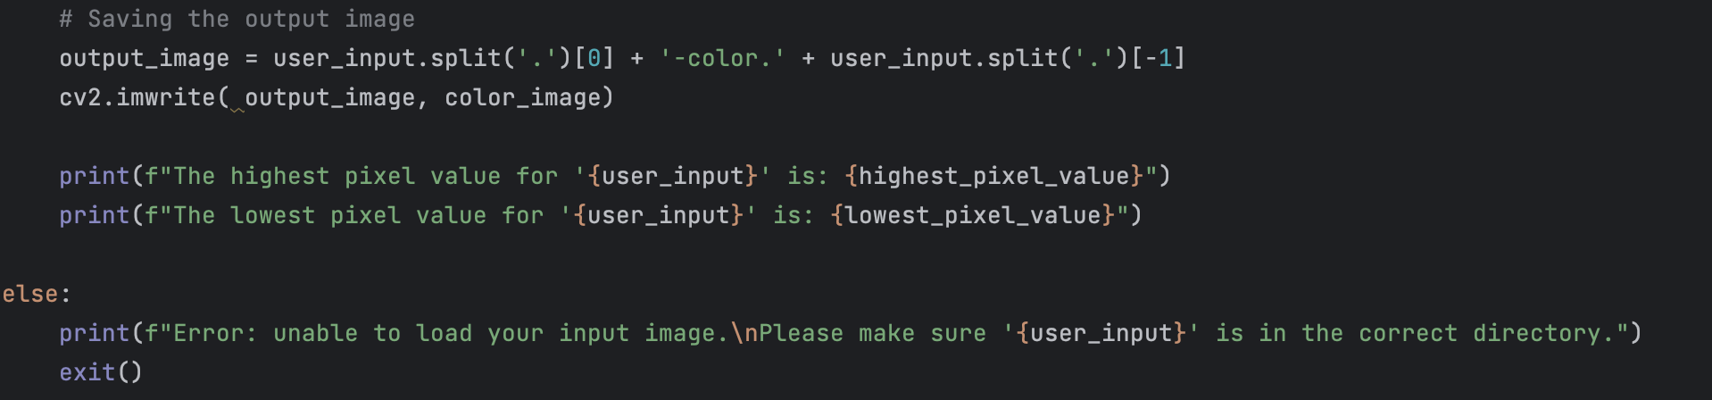

Figure . Code used for saving output images.

**PS2 Read me text file**

24-678: Computer Vision for Engineers

Ryan Wu

ID: weihuanw

PS2 Converting a grayscale image to a pseudo-color image

Operating system: macOS Ventura 13.5.2

IDE you used to write and run your code: PyCharm 2023.1.4 (Community Edition)

The number of hours you spent to finish this problem: 12 hours.